Curriculum Vitae (C.V.)
- Personal data:
Name (Arabic) | احمد مصطفى إبراهيم ابوسقاية
Name (English) | Ahmed Mostafa Ibrahim Abosakaya
Department | Anesthesia, ICU, and Pain therapy
College | Benha Faculty of medicine
Academic degree | MD
Office Address
Mobile 1 | 01006505806
Home phone | 01508365806
Work phone
Fax
Email (university) | ahmed.aboskayah@fmed.bu.edu.eg
Email (alternative) | ahmed_sakaya@yahoo.com
Web site (if any) | Ahmed Abosakaya
Recent Photo (passport format) | 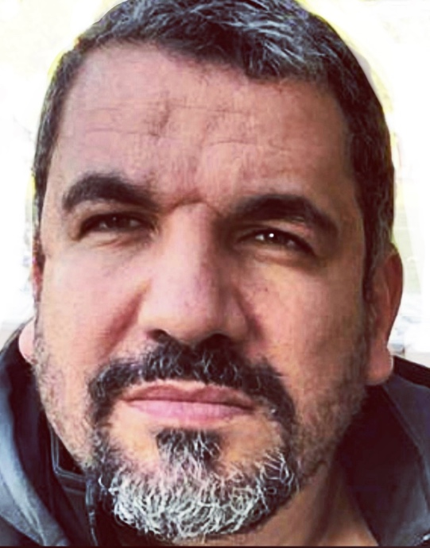
- Education:
2.A. Degree obtained;
Institution | Degree obtained | Year
Benha faculty of medicine | MD | 2013

2.B. Specialty;
General specialty. | Anesthesia
Specific specialty. | Anesthesia for cosmetic surgery

2.C. Language skills (Excellent, Very Good, Good or Basic);
Language | Reading | Speaking | Writing
Arabic. | Perfect | Perfect | Perfect
English. | Excellent | Excellent | Excellent
French.
Other (specify).

- Positions:
Tittle | Year | University/Institution
Lecturer | 2013 | Benha university

- Cooperation with local and international entities having website:
( جامعة – مؤسسة - وزارة – مركز بحثي – عضو هيئة تدريس – باحث - شركة – مصنع – الخ)
Name of local and international entity | Website
- Membership of professional bodies (List):

- Membership of institute (List):

- Distinction and Awards (List):

- Academic:
Courses at under graduate level;
1. Course name:  General anesthesia and spinal | Clinical rounds;
2. Course name:  Pain types and physiology | Lectures;
Courses at post graduate level;
1. Course name: anesthesia | Clinical rounds;
2. Course name:  Icu and pain | Lectures;
- Areas of research:

- PhD/M.Sc Supervision:
Title | PhD/M.Sc | Year completed / in progress
Check my website

- Grants for Projects:
Funding organization | Project title | Role | Year
- Committees:

- List of Publications: check my website

14. Attended Workshops, Symposiums, and Conferences: "List name and year";

Name of Workshops, Symposiums, and Conferences | Year
13.1. Check my website | 2005

- Books published:

16. Positions:
 | Date | Organization | Country | Position
1
2
3

17. Activities in faculty/university/community service:
Name of Activity service | Year
- Teaching (Rounds and lectures).
- Clinical meeting.
- Making conferences.
- Medical Convoys.
- Workshops.
18. Consulting Experience (if any):

19. Additional information you would like to put on the website:

